The Magic of Pause

This is age of being connected and online all our waking hours; even remaining available in between snatches of sleep. We lead a fragmented life where multi-tasking (scatter brained) is the order of the day and demand of life. The drive to respond in real time leaves no time to lollygag; the word and the ability both forgotten !!

In our attempt to live life to the fullest we may simply be leading a frenzied and schizophrenic existence.

When I was young we played a game of 'statue'. When a friend commanded or called out "statue", all kids within earshot and who had previously consented to be part of, would freeze. Had to 'freeze' mid action no matter what, not allowed to twitch or move a muscle. This until 'over' was similarly called out. Picture Jim Carey in 'Mask'; how he freezes mid air! It was so much fun - ROTFL was not merely an expression, it was experience. I have appropriated (snatched) my "statue" friends' raw mangoes, lunch box, sweets and treats, cricket ball, football and what not. And I have similarly 'given' (shared) stuff dear to me.
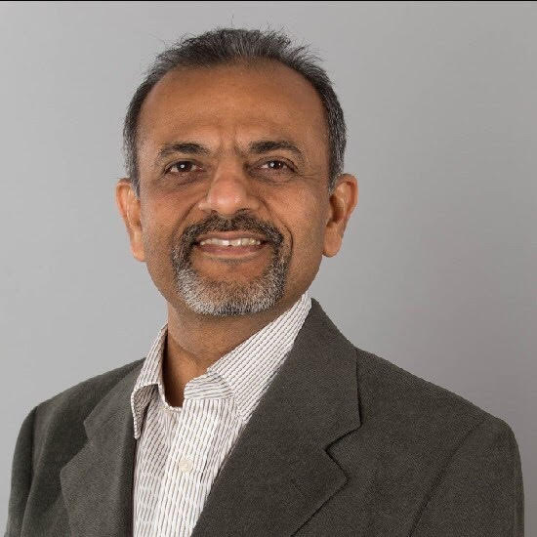
Childhood doesn’t last but its memories do. I miss my childhood and specifically this game of 'statue". The "statue" command I miss most because of its power to halt life; to bring it to "Pause". To fully harvest that moment. I wish I retained this ability, to Pause when I held my daughter few moments after she was born, Pause when she took her first steps, Pause when she uttered her first word, Pause when I sampled first ever dish (beetroot ravioli) my son cooked as a chef........Pause the sunset I watched over the Simien mountains. Pause when.... my list is long as my arm. Moments that I wish I had completely immersed myself, lost myself to, forever 'freeze' in my heart. I see you nod in agreement. Perhaps your list as long, if not longer.

If life has a destination, then all of our lives are going headlong towards that common destination- death! Surely that can’t be purpose of life, and it isn't. Life is meant to be a journey full of moments to be savored. Don’t rush those moments, take your time. Will you regret arriving late at that ultimate destination? The later you arrive the more enriched your life is likely to have been. It is on everyone's mind to prolong the journey; with appropriate 'Pauses" you will enrich it, too.

So pause when you see love in those eyes, pause when you hug a loved one, pause when you say goodbye, pause when you see that glorious sunrise or sunset, pause when you hear laughter, pause when someone’s eyes are moist, pause when someone is crying out for you, pause when you have a slow driver ahead of you, pause to let other drive in to the lane, pause to thank someone who held the door open, pause to hear someone and pause when you are talking too much!!! In the doingness of life, we have lost our beingness. "Pause" restores that balance.

Pause - to add years to your life and life to your years.

"Pause" is part of an effective Toastmasters repertoire. "Pause" so that your audience catches up! Do not be 'motor-mouth' we hear often! Don't speak as quickly as your mind "thinks".

Music happens between notes and life happens when you pause between moments - pause and life will shower everything that moment has. Pause because you want to take in life, pause so that you may drink that moment deeply till you are full.

To see a World in a Grain of Sand, And Heaven in a Wild Flower
Hold Infinity in the palm of your hand, And Eternity in an hour
Auguries of Innocence
BY WILLIAM BLAKE

"Pause" !

.

